**Binding APIs to CAI Chatbot**

**Prerequisites**: Running API endpoints, completed previous 2 tutorials

**Result**: Running CAI chatbot with single action connected to API endpoint

**1. Log in to the Platform**

Go to <https://cai.tools.sap/> . Before you use the platform for the first time, you need to sign up and create your user account.

**2. Create Your Chatbot**

Click *+ New* Bot at the top right of the page in SAP Conversational AI and create your first chatbot.

1. Select Perform Actions option for chatbot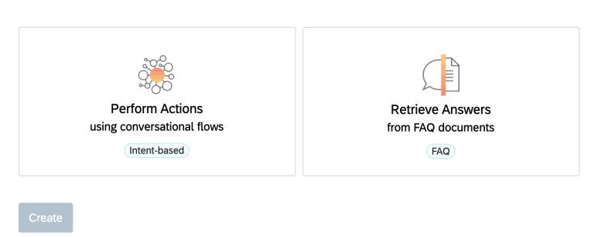
2. Select greetings predefined skill for your bot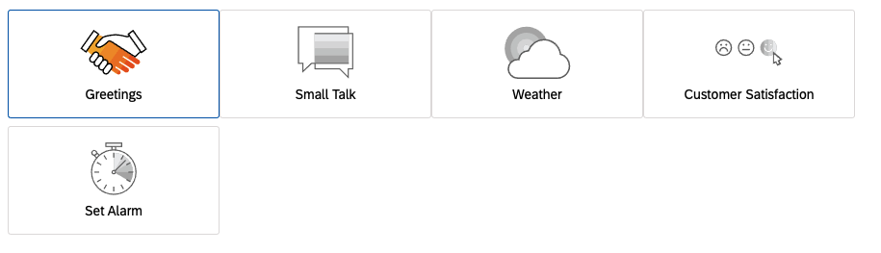
3. Create your bot:
   1. Enter a name and, if desired, a description for your bot.
   2. (Optional) Add up to six topics to your bot. By categorizing bot in this way, CAI can suggest more appropriate training data to improve it later on.
   3. Set default language as English

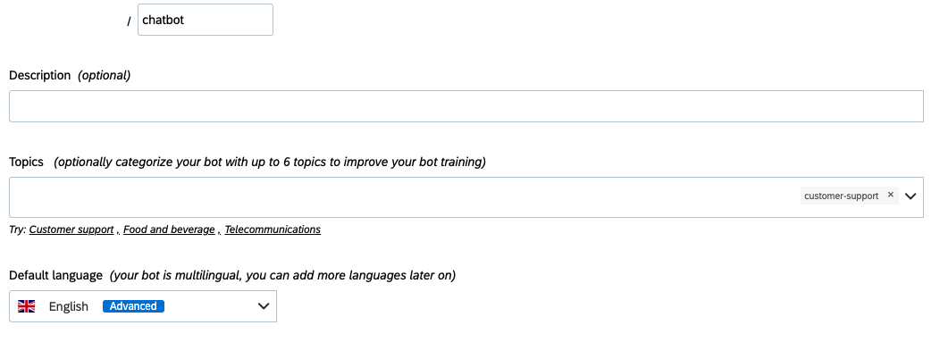

1. Select your data policy according to [Bot Data Policy settings.](https://help.sap.com/viewer/3aab817a03be4432abbfd00c42b23cb8/latest/en-US/65a2096b1eea4c48ae3e609d049707a3.html)

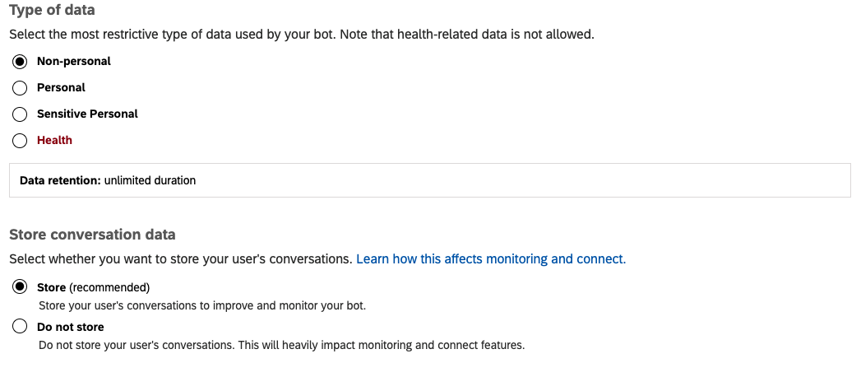

1. Set your bot visibility. And create your bot.

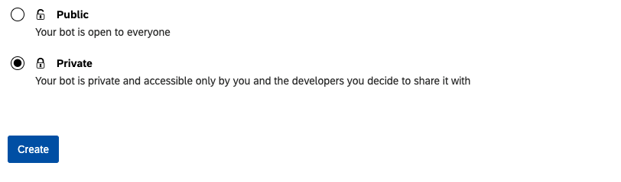

**3. Creating Sales Order Intent**

An intent is a collection of sentences that all have the same meaning, even though they can be very different from one another. When a user sends a message to your bot, CAI algorithm predicts the intents to which it’s close enough and decides what the intention of the message is.

Everything your chatbot understands is in the intents. Each intent corresponds to an action that your user wants to perform. For example, the intent greetings enables your bot to understand when a user says Hello. Explore each intent by clicking the name of the intent (for example, greetings), and you’ll see the expressions inside that train your bot to understand the user’s intent.

1. Click + New Intent button to create a new intent.

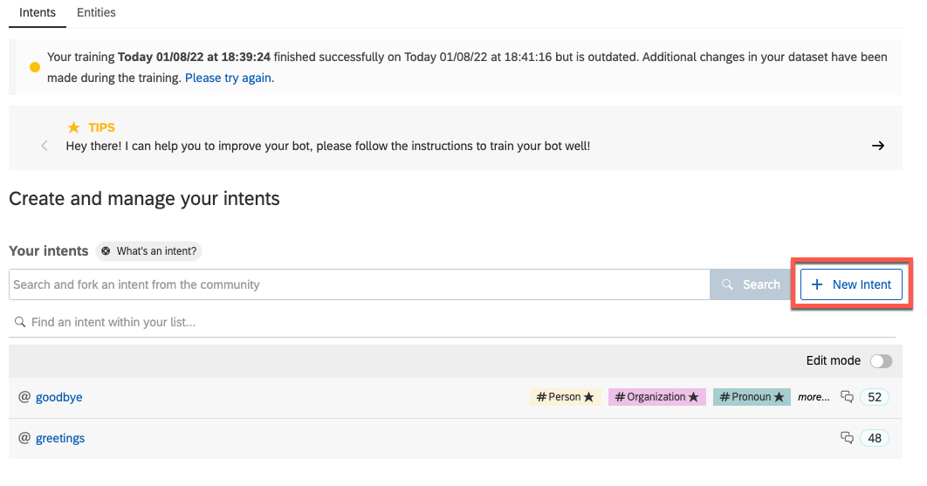

1. Name Your Intent and decide set your matching strictness to 50

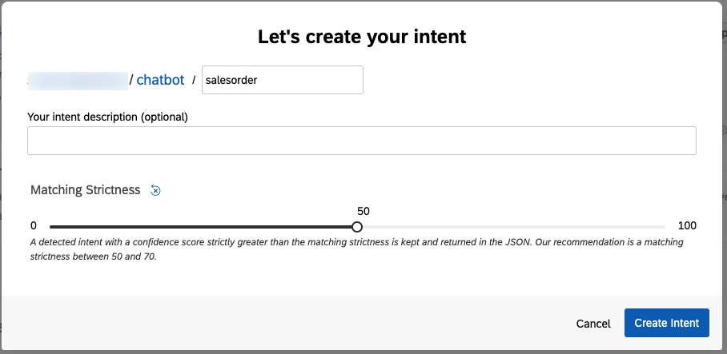

1. Click the salesorder intent and add your expressions to train your intent. Try to add more than 50 expressions per intent at least for better training of chatbot.

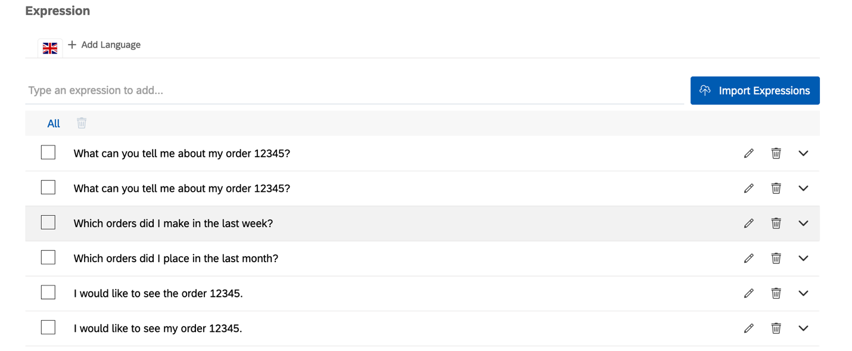

**4. Create Sales Order ID Entity**

An entity is a keyword that is extracted from an expression. CAI automatically detects [28 different entities](https://help.sap.com/doc/9b639cad3d734675971ab22ed10bbf28/latest/en-US/UserGuideToConceptsOfSAPConversationalAI.pdf#page=55&zoom=100,0,541), such as Datetime, Location, Person, and so on. However, we’re not limited to these gold entities. We can create a custom entity like Sales Order ID.

1. Navigate to entity tab in Train tab.

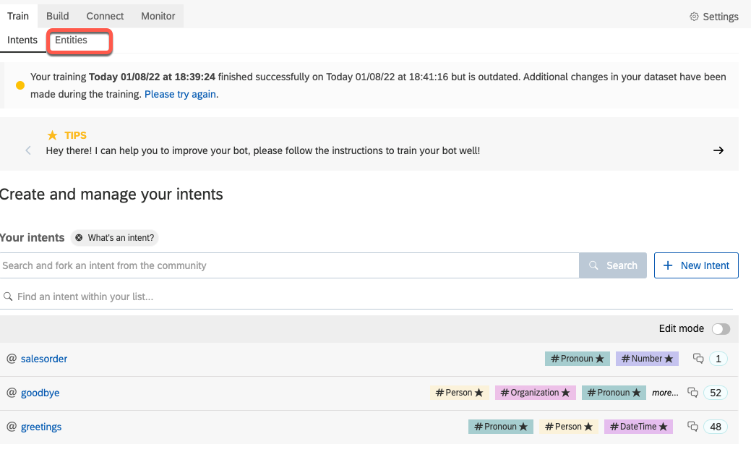

1. Create your free entity with sales-order-id name and 50 matching strictness

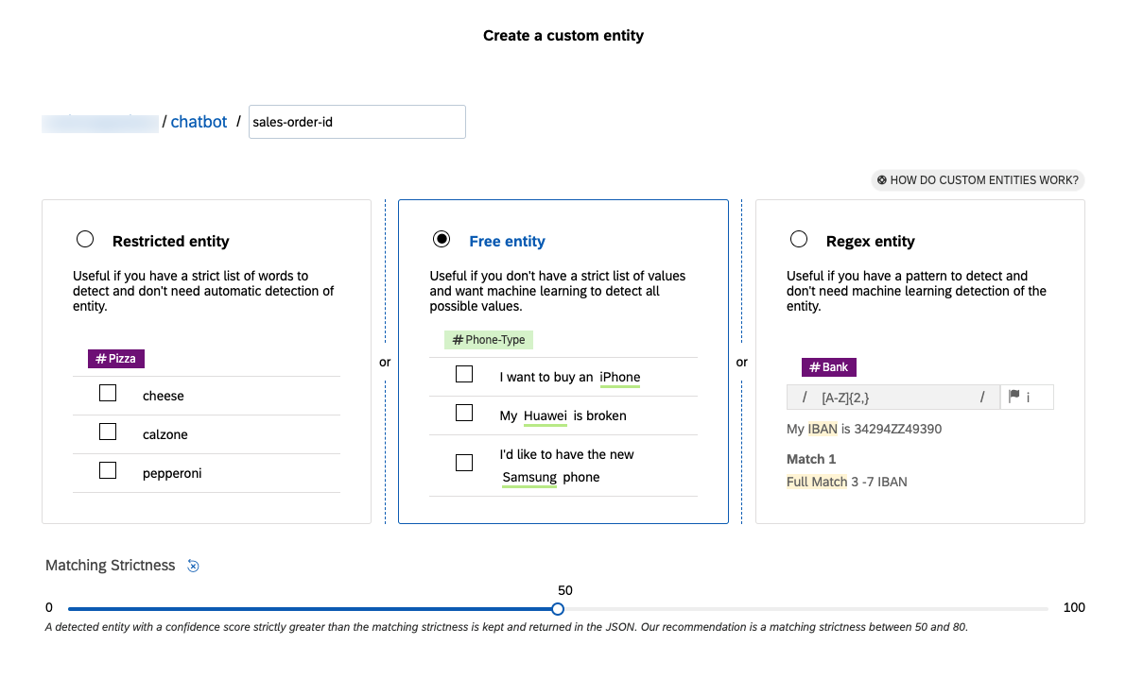

1. Now go back to your salesorder intent and expand your expressions and tag your entities like below

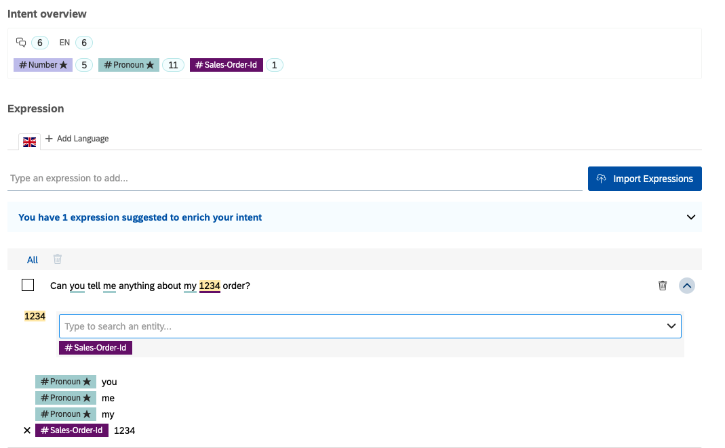

**5. Create New Skill**

A skill is a block of conversation that has a clear purpose and that your bot can execute to achieve a goal. It can be as simple as the ability to greet someone, but it can also be more complex, like getting details of an order according to information given by user. You can add a skill to your bot on the Build tab by clicking Add skill in the command panel on the left. You can add as many skills to your bot as you wish.

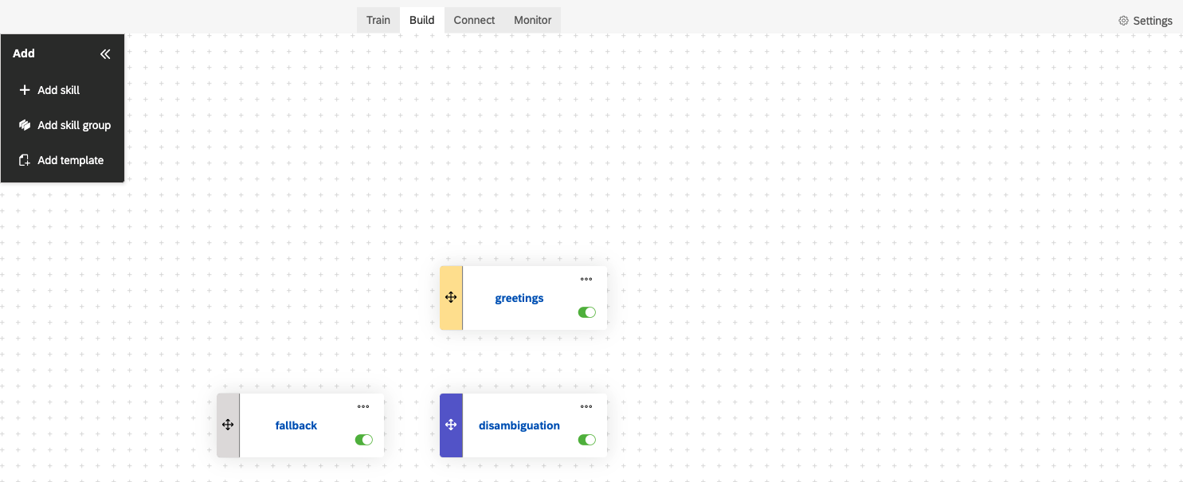

1. Create your business skill named salesorder and open your skill by clicking on it

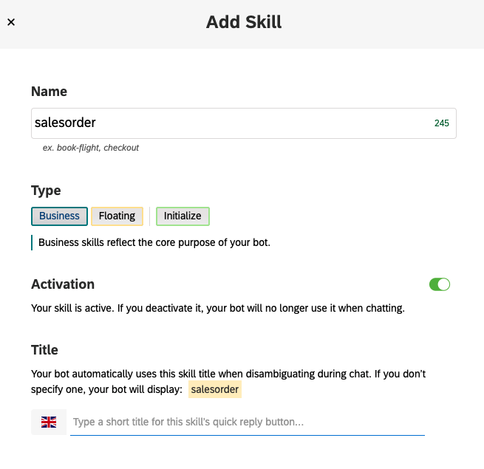

1. Set trigger for your action

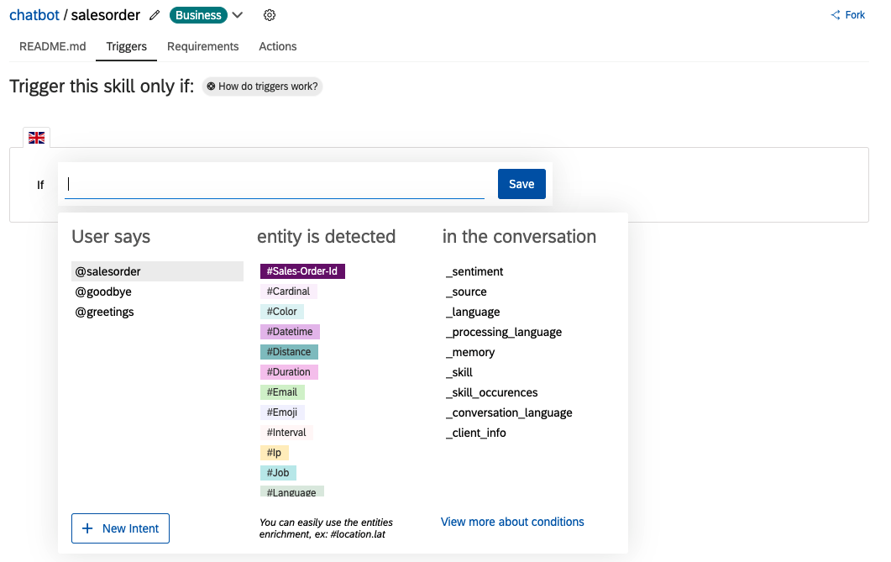

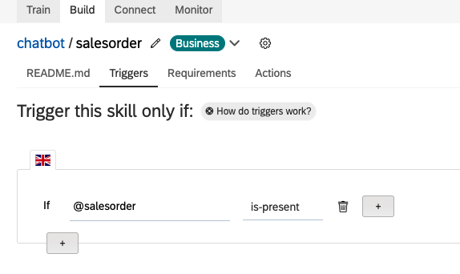

1. Set your requirements for action as below

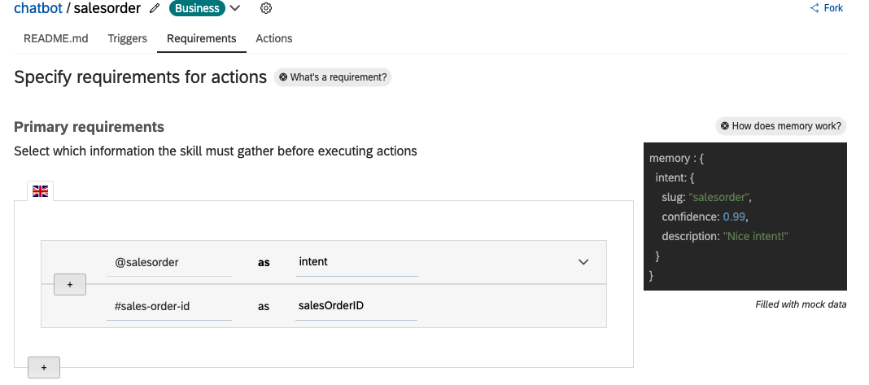

1. Add condition for your action

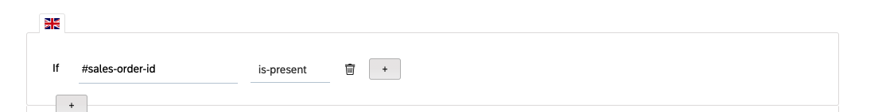

1. Create your action in Actions tab
   1. Select connect external service. We can select either call webhook or consume API service. We will use consume API service since our TestSalesOrder service is only OData endpoint. To use webhooks, we need [special response formats.](https://help.sap.com/viewer/a4522a393d2b4643812b7caadfe90c18/latest/en-US/7f06277acb1d46529daa9c5828a8a045.html)

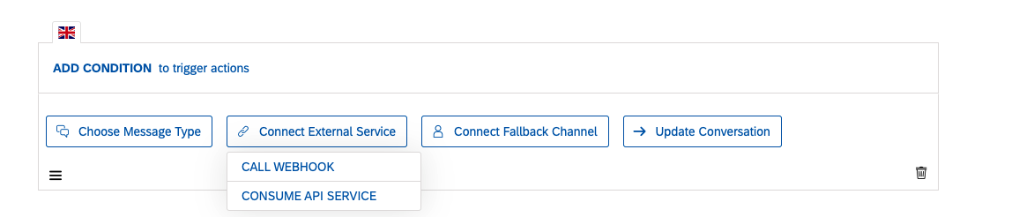

* 1. Define your API request

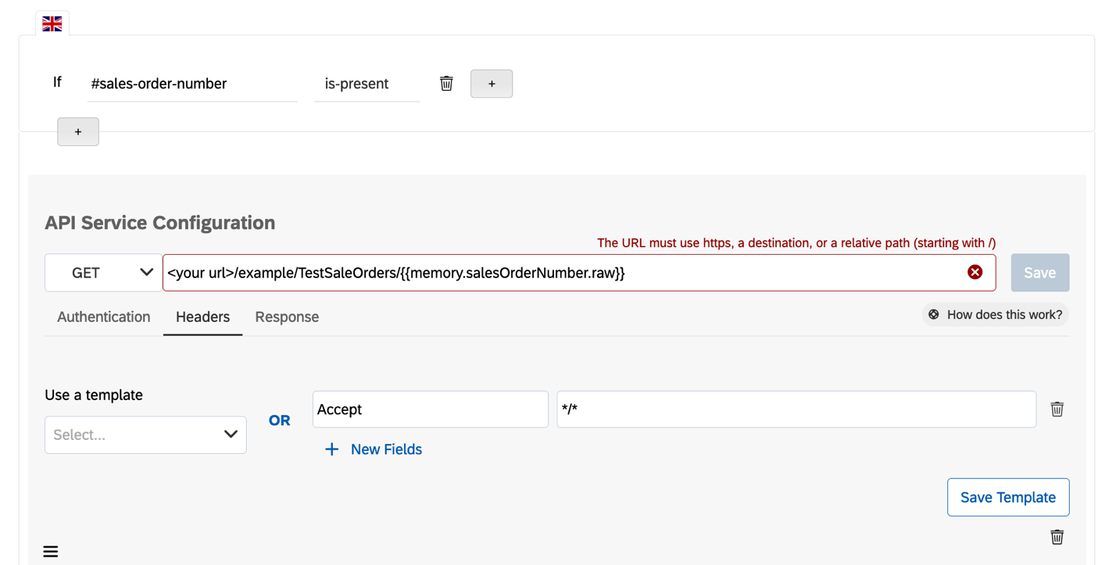

* 1. Select choose message type -> custom and in the message type select card and replace script with below

{

"type": "card",

"delay": "",

"content": {

"title": "SALES ORDER {{memory.salesOrderID.raw}}",

"subtitle": "Type: {{api_service_response.default.body.SalesOrderType}} Date: {{api_service_response.default.body.CreationDate}}",

"description": "Total Net Amount: {{api_service_response.default.body.TotalNetAmount}} {{api_service_response.default.body.TransactionCurrency}}",

"status": "{{api_service_response.default.body.OverallSDProcessStatus}}",

"statusState": "information"

}

}

* 1. For the final step select update conversation -> edit memory and delete the salesOrderID.

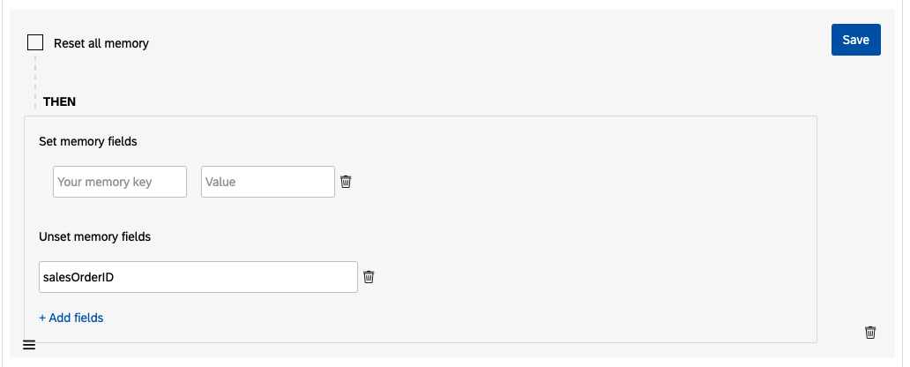

1. **Test Your Skill**

You can test your chatbot by clicking chat preview at the bottom right corner of the page.

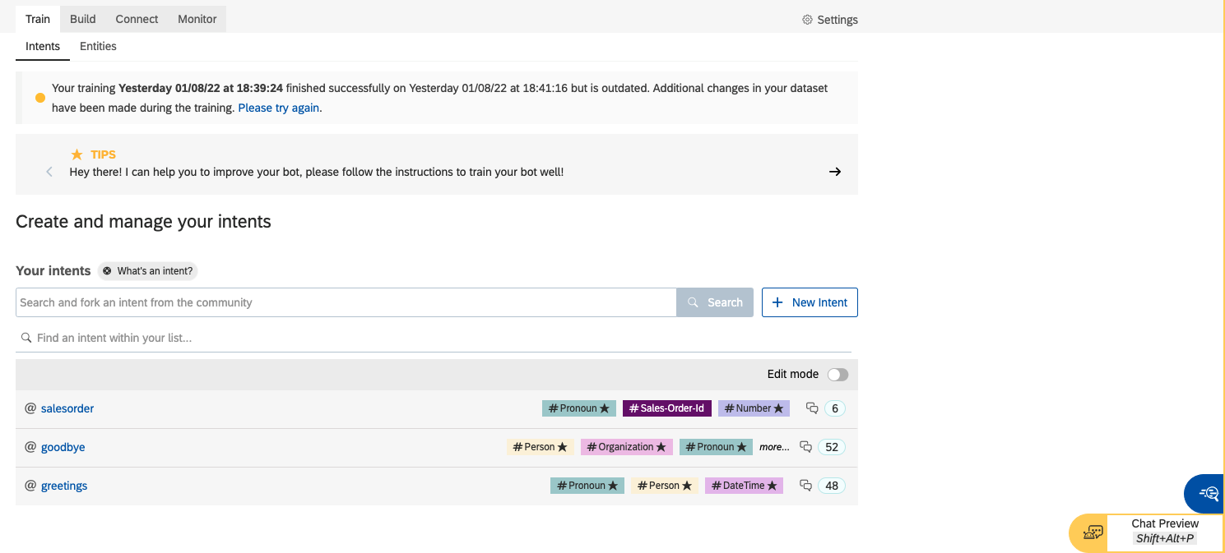

After opening chat preview you can also open the debug area for details of your chatbot events. 